**Daily Assessment**

**Muhammad Ammar Chaudhry**

**SU92-BSCSM-F23-269**

**BSCS-1G**

**----------------------------------------------------------------------------------------------------**

**Q # 71:**

#include <iostream>

using namespace std;

int main()

{

int frequency[10] = {0};

long long num;

cout << "Enter an integer: ";

cin >> num;

if (num < 0)

{

cout << "Please enter a non-negative integer." << endl;

return 1;

}

while (num > 0)

{

int digit = num % 10;

frequency[digit]++;

num /= 10;

}

cout << "Digit frequencies:" << endl;

for (int i = 0; i < 10; ++i)

{

cout << "Digit " << i << ": " << frequency[i] << " times" << endl;

}

return 0;

}

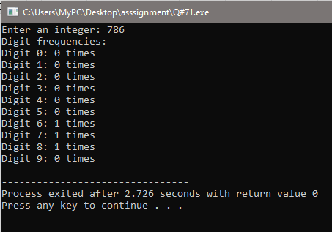

**Q # 72:**

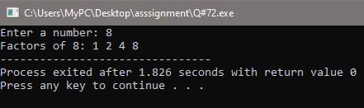

**Q # 73:**

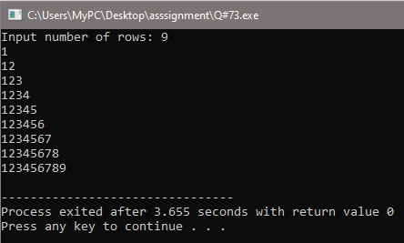

**Q # 74:**

#include <iostream>

using namespace std;

int main()

{

int numRows;

cout << "Input number of rows: ";

cin >> numRows;

for (int i = 1; i <= numRows; ++i)

{

for (int j = 1; j <= i; ++j)

{

cout << i;

}

cout << endl;

}

return 0;

}

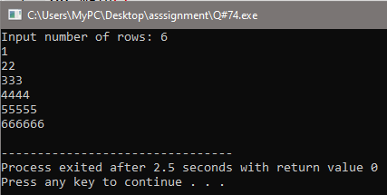

**Q # 75:**

#include <iostream>

using namespace std;

int main()

{

int numRows;

cout << "Input number of rows: ";

cin >> numRows;

for (int i = 1; i <= numRows; ++i)

{

for (int j = 1; j <= i; ++j)

{

cout << "*";

}

cout << endl;

}

return 0;

}

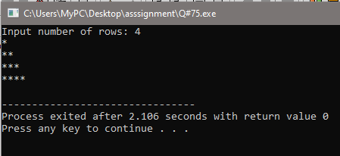

**Q # 76:**

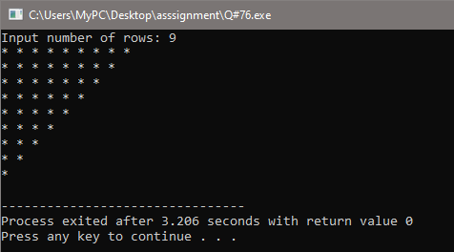

**Q # 77:**

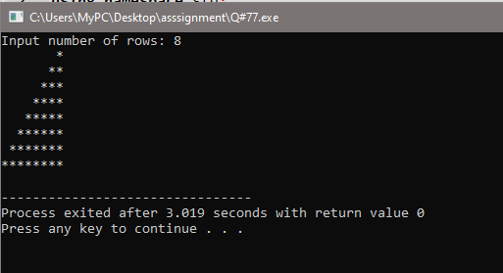

**Q # 78:**

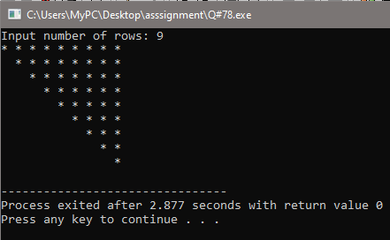

**Q # 79:**

#include <iostream>

using namespace std;

int main()

{

int numRows;

cout << "Input number of rows: ";

cin >> numRows;

int currentValue = 1;

for (int i = 1; i <= numRows; ++i)

{

for (int j = 1; j <= i; ++j)

{

cout << currentValue << " ";

++currentValue;

}

cout << endl;

}

return 0;

}

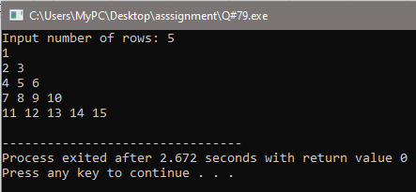

**Q # 80:**

#include <iostream>

using namespace std;

int main()

{

int numRows;

char startChar;

cout << "Input number of rows: ";

cin >> numRows;

char ch = 'A';

for (int i = 1; i <= numRows; ++i)

{

for (int j = 1; j <= i; ++j)

{

cout << ch << " ";

ch++;

}

cout << endl;

}

return 0;

}

